**POULTRY MANAGEMENT SYSTEM**

**(CASE STUDY OF ONE HEN COMPANY)**

**RISPER NYAMBEKI ANYONA**

**1253­­­­/LCK/BS/2020**

**A PROJECT PROPOSAL SUBMITTED TO THE DEPARTMENT OF INFORMATION COMMUNICATION TECHNOLOGY IN THE SCHOOL OF BUSINESS IN PARTIAL FULFILLMENT FOR THE DIPLOMA OF INFORMATION COMMUNICATION TECHNOLOGY OF LUKENYA UNIVERSITY.**

**SEPTEMBER 2021**

# DECLARATION

I hereby declare this project as my original work arrived through reading and research.it has not been published or submitted to any university or higher institution of learning of any academic award.

RISPER NYAMBEKI ANYONA

1253/LCK/BS/2020

SIGN………………. DATE ………………….

SUPERVISOR: MR STANLEY MULI.

SIGN…………………… DATE…………………..

# 

# DEDICATION

I humbly dedicate this work to my supervisor Mr. Stanley, my tutors Mr. jimmy, Mr. joseck and Mr. James .my beloved parents Mr. and Mrs. jane anyona and my beloved brother and sisters at large for their support and their commitment in prayer towards the success of my education and also offered financial support throughout my research work. I thank almighty God for his guidance and protection for helping me reach this level and also thank those who enabled me realize my ambition.

# ACKNOWLEDGEMENT

My acknowledgement goes to my supervisor Mr. Stanley Muli, Mr. Josseck Omwoyo and Mr. Jimmy Makau for their support, guidance and encouragement towards the success of this work. I also acknowledge the entire administration of Lukenya University at large for offering me an opportunity to pursue this course and also sincere thanks to all my lecturers and staff for their effort and dedication during the course, may the almighty God shower you with his everlasting blessing.

# ABSTRACT

Poultry rearing in one hen company has been facing a lot of challenges for instance poor record keeping, Which involves storing documents manually in files this may lead to loss of data and also tiresome to work on paper and time consuming too since one has to go back to files to check for data, also clients visiting the company in person for services is a problem too.

The proposed poultry management system will solve the problem of record keeping by storing data in a way that it’s easy to retrieve when in need, reduce paperwork by use of an online poultry management system and also clients will be able to reduce the problem of customers queuing for manual registration, payment done by customers will be made easy and also the customers are able to log into the customers module and then check for the feeds available and make an order.in order to solve this problems I propose to develop a better system of the company, to achieve the objective I chose one hen as a case study because of its strategic position .I will use the admin module ,customer module, report module, supplier module.

Poultry management system is web-based application software that will help in carrying out the entire activities performed in the farm. I will use the following languages in the front-end PHP, html and JavaScript while in the backend I will use MYSQL for database.

Table of Contents

DECLARATION 2

DEDICATION 3

ACKNOWLEDGEMENT 4

ABSTRACT 5

CHAPTER ONE 8

1.0 INTRODUCTION 8

1.1 BACKGROUND OF THE STUDY. 9

1.2 STATEMENT OF THE PROBLEM. 10

1.3 PROPOSED SOLUTION 11

1.4 OBJECTIVES. 12

1.4.1 GENERAL OBJECTIVES. 12

1.4.2 SPECIFIC OBJECTIVES. 12

1.5 SIGNIFICANCE OF THE STUDY 13

1.6SCOPE OF THE STUDY. 13

CHAPTER TWO 14

LITERATURE REVIEW 14

2.1 INTRODUCTION 14

2.2 REVIEW OF RELATED SYSTEMS 15

2.2.1 TYSON FOOD COMPANY 15

2.2.2 SOUTH AFRICA POULTRY ASSOCIATION. 16

2.2.3 NEOCHICKS POULTRY LIMITED 16

2.4 PROPOSED SOLUTION 17

CHAPTER THREE 18

RESEARCH METHODOLOGY 18

3.0 INTRODUCTION. 18

3.1 PROJECT DESIGN 18

3.2 DATA COLLECTION METHODS 19

3.2.1 TARGET POPULATION. 19

3.3.2 METHODS OF DATA COLLECTION. 19

3.4 SYSTEM REQUIREMENTS 21

3.4.1 HARDWARE REQUIREMENTS. 21

3.4.2 SOFTWARE REQUIREMENTS 21

CHAPTER FOUR 22

SYSTEM ANALYSIS AND DESIGN 22

4.1 PLAN FOR REQUIREMENTS 22

4.2 FUNCTIONAL REQUIREMENT 23

4.3 Non functional requirements 23

CHAPTER FIVE 24

TESTING AND IMPLEMENTATION 24

5.1 Features to be tested 24

5.2 Test cases 25

5.3 Testing Schedule 25

5.4 Pert chart testing 25

5.4 Implementation 26

5.5 System modules codes 27

CHAPTER SIX 57

SYSTEM MAINTENANCE 57

CONCLUSION 58

PROJECT TIME SCHEDULED 59

APPENDIXES 60

PROJECT BUDGET 60

GANT CHART. 61

References 62

# CHAPTER ONE

## 1.0 INTRODUCTION

One hen company started over the past few years, whereby it is used to produce chicks, feeds, chicken to farmer’s .It’s located in kisii at keroka .The customers and the suppliers use a manual system in the processing which is tiresome both to the customers and the supplier in order to fasten the process and simplify this manual poultry management system. I propose to come up with a system that is promising to the company in order to enable transaction, registration of customers, ordering of products and also display of sold products report.

With the proposed system it can help the farm to speed up the transactions and service their products effectively and the company sale their product quickly hence more customer thus creating more income to the company and ensuring customer satisfaction.

## 

## 1.1 BACKGROUND OF THE STUDY.

One hen company started in the year 2010 as a result of reducing poverty in the area through encouraging farmers to rear poultry and providing market to the farmer’s products such as chicken, chicken manure which was a major problem in the area.

Research shows that suppliers, have to go to the company to request to make orders to supply for feeds while the customers have to go physically to buy the products then no report is generated to account for the products sold and products in the store which is tiresome to suppliers and time consuming to customers rendering the process unfavorable. There has been many complains by suppliers to the company in record keeping because some of the transaction are lost in the files. I propose to come up with a system which allows the customers and suppliers make orders and enquire if there is the products that the company needs and also debug record keeping.

## 1.2 STATEMENT OF THE PROBLEM.

Poultry management system in One Hen Company is paperwork based hence inefficient, tiresome and hard to update.

There have been a lot of complain by the supplier whereby after supplying the food and other types of chicken the record kept may end up missing since its daily records and the transaction is more. More time is also wasted in the whole process of giving service and recording.

## 

## 1.3 PROPOSED SOLUTION

I propose to develop a system that will reduce the following, customers are able to make requests and delivered in time and also suppliers won’t be going physically instead they will view orders in the system and deliver products, also able to generate reports for customers and this will eliminate the manual way to a computerized system and this reduce the time the customers use to visit the company physically.

The supplier can request for an order and supply the products while in the customer’s module they are able to make orders, pay and also view commodities available.

## 

## 1.4 OBJECTIVES.

## 1.4.1 GENERAL OBJECTIVES.

The main aim of this project is to develop a poultry management system that will enable farmer’s access services, make orders this will improve production and reduce time used by distant customers to visit the company for services.

## 1.4.2 SPECIFIC OBJECTIVES.

1. The system will allow the admin to view, edit and add customer’s details.
2. The system will allow customers to make their orders
3. The system will allow report generation for customers and suppliers record.
4. The system will allow the suppliers make their orders.

## 1.5 SIGNIFICANCE OF THE STUDY

Poultry management system will help the people of keroka and to acquire skills on poultry farming through organizing seminars educating them on the importance of chicken rearing and this will reduce poverty within and outside the region

## 1.6SCOPE OF THE STUDY.

This research will take place in KEROKA within NYAMIRA COUNTY after involving the residents of the area since the system will help them greatly in their farming.

# 

# CHAPTER TWO

# LITERATURE REVIEW

## 2.1 INTRODUCTION

Poultry farming is practiced across the world by many people in their daily life this practice is mainly done by individuals.

Poultry plays important role for mankind through food supply, income creation, and generation of jobs and provision of raw materials to some industries facilitating research work.

(Pym et al…2006) says family Poultry makes up to 80% of poultry stocks in countries with low income owners .poultry is raised in small numbers ranging from single birds up to a few hundred birds.

Poultry rearing across the world reduces poverty whereby a farmer is able to sell the hens and their product to earn a living.

The practice comprises of production of chicks, feeds and chicken to farmers in the area and also reduce poverty in the area by encouraging farmers to rear poultry.

Poultry management system endeavors in improving services by reducing paperwork, poor record keeping and also farmers will be able to access services online and also make orders and inquiries of some products.

2.2 REVIEW OF RELATED SYSTEMS**.**

## 2.2.1 TYSON FOOD COMPANY

Tyson is a company sponsored by Rockwell Automation which helps in easy troubleshooting and compliance reporting.

It’s one of the largest producers of meat and poultry in the world it also raises chicks, sells animal feeds and transporting chicken to the market.

The company experiences problems such as weekly system crashes since the plant was relying on old pc hardware ,which was in turn ,limiting which software system was used .some hardware’s could even run the 90s programmers .

“Jonathan Riechert “the senior engineer innovation, corporate engineering group, Tyson foods said that.

“Beyond the USDA reporting issue, we knew that we couldn’t keep taking hours out of employee’s days to troubleshoot.”

^abcde”Tyson foods produces solid fourth quarter ,fiscal 2019 earnings “www.tyson foods .com.retrieved September 22, 2020.

## 2.2.2 SOUTH AFRICA POULTRY ASSOCIATION.

The poultry industry consists of day old chick supply industry, the broiler and egg industry.

The South Africa poultry association was established in 1904 being the largest producer of in agricultural sector .SAPA (9) (2018) South African poultry association industry profile.

## 2.2.3 NEOCHICKS POULTRY LIMITED

It’s a poultry farm in Kenya offering advanced poultry incubators where you can hatch eggs the incubators are of quality and elegance and you can comfortably place them in your table room.

Being one of the best poultry farms in Kenya, neochicks offers quality indigeneous eggs. The eggs are fertile and when he arched they produce healthy chicks, finally one can get nutritious poultry feeds from neochicks to feed poultry

**2.3 WEAKNESS OF THE SYSTEMS**

Use of old pc hardware which in turn brings problems such as system crush whereby the system has less amount of database storage hence unable to store huge amount of data for customers, leads to loss of visibility in production and also the customers unable to trace them.

High cost of feeds, which will be used to feed the poultry.

The purchase of incubators is expensive since the application can be vigorous and competitive.

## 2.4 PROPOSED SOLUTION

I propose to come up with a system that uses a new hardware that will reduce the problem of crushing and also reports will be up to date to reduce running the old programmes.

Manufacturing own feeds from the company to feed poultry.

Use of natural incubators which is suitable and less laborious since it does not involve inspection and turning the eggs.

# CHAPTER THREE

# RESEARCH METHODOLOGY

## 3.0 INTRODUCTION.

I propose to use the system development life cycle in the development of my system. since the poultry management system involves a step by step procedure. Poultry management is a web based that will enable farmer’s access services, make orders this will improve production and reduce time used by distant customers to visit the company for services.

## 3.1 PROJECT DESIGN

I will use descriptive survey design in conducting this study. descriptive survey design is appropriate because it involves collecting data from targeted customers to test hypotheses or answers questions about the current status of the study’s subjects.

To come with my project, I propose using the system development life cycle .This is because it allows you to effectively plan and follow a software development process step by step ,making it as predictable as possible. Each step comes with its own approach to the software development process.

## 3.2 DATA COLLECTION METHODS

## 3.2.1 TARGET POPULATION.

Study population is a sample representation of a group of people in one Hen Company.

I will take a sample from the manager, and 3 workers. Out of 20 workers in that company for my study. The reason of taking a sample it will help me in getting more information about the company.

The study population is the manager, workers and the staff.

## 3.3.2 METHODS OF DATA COLLECTION.

The following are the methods to use to collect information.

1. Observation.

2. Questionnaires.

**OBSERVATION**

I will observe the activities in the poultry farm and how the management will disperse the application forms .by use of phenomena of observing the customers behavior on human interactions in the farm.

Reasons for using observation.

* It’s an observation by use of a naked eye hence able to observe directly.
* Data collected through observation is very accurate and reliable since I will have observed by my own eyes.

**QUESTIONNAIRES**

I will use a series of questions by sending to customers, suppliers and the staff and require them to fill the information that I require them to fill in order to come up with a system that will be user friendly to users.

**Reasons for choosing questionnaires**

1. It helps in uniformity of questions hence all questions are the same hence makes easy response to answers.
2. It is an easier method because it can be issued out easily and it contains first hand data from respondents hence will help me interact with the customers and get information from them.
3. **3.3.3 Design procedure**

I propose to use the system development life cycle to develop my project it entails the following steps;

1. Feasibility study-I will use feasibility study to determine whether the project should get a go ahead.

2. Problem identification –investigation of the system problem that affect the end user of the system is done in this phase.

3. System analysis- I will use special tools to do a requirement determination of the organization current procedures and the information systems used to carry out the organizational task.

4. Designing of the system-I will use the information I had collected earlier to accomplish the logical design of the information system.

5. Development of the system –I will use programming skills to design the system.

6. Testing the system-I will check the errors in the system and ensure that there is none before signing the system to users.

7. Implementation-I will implement the system and train the users how to handle the system.

## 3.4 SYSTEM REQUIREMENTS

## 3.4.1 HARDWARE REQUIREMENTS.

|  |  |
| --- | --- |
| COMPONENTS | MINIMUM REQUIREMENTS. |
| RAM | 2.00GB |
| HARD DISK DRIVE | 320GB |
| CHACHE MEMORY | 2MB |
| INTERNET | Modem |
| BASIC COMPONENTS | Battery ,mouse and standard  QWERTY keyboard |

Table 1: hardware requirements

## 3.4.2 SOFTWARE REQUIREMENTS

|  |  |
| --- | --- |
| COMPONENTS | MINIMUM REQUIREMENTS |
| OPERATING SYTEM | Microsoft windows 10 |
| GRAPHICS | Intel HD graphics |
| FRONT END | PHP,JAVASCRIPT |
| BACK END | My SQL |

Table 2: software requirements

# CHAPTER FOUR

# SYSTEM ANALYSIS AND DESIGN

## 4.1 PLAN FOR REQUIREMENTS

The initial purpose is to determine the business case developed by the stakeholders. We want to understand how One Hen Poultry Farm works, how frequently the program will be utilized, and whether the end solution can handle all of the information management.

**Elaboration task:**

During this stage, information obtained during the conception and elicitation stages is put together and polished. A model is created that depicts the many situations of the software's function and behavior. Scenarios were developed to depict and help understand how consumers and suppliers would engage with the system, as well as how staff will interact with the program. Any properties, as well as how each function interacts with one another, must be specified.

**Negotiation task:**

Any disagreement that arose that needed to be resolved was discussed by the team and stakeholders in order to come up with a solution. If the stakeholders ask for too many criteria, we will have them rate them in order of significance. To save time and money, anything that turns out to be the bottom requirements by all, if not most, stakeholders may have to be deleted.

**Specification task:**

During this task, we plan to create a software requirements specification template. In this template we will note down the overall purpose of the project and the intended audience. Descriptions regarding the product features, user class/ characteristics, operating environment and design will be included. Also included are safety and security requirements, quality attributes, and what interfaces are to be used with this software.

**Validation task:**

During this stage, any requirements stated are to ensure that they are clearly defined. No miss-interpretation should be present and any that exist should be resolved. All and any sources or stakeholders used in the project planning should be proved legitimate and their input is 100% valid for use. All the requirements should be congruent with the overall objectives and can be easily understood. Any hard-to-understand phrases should be rewritten and discussed over and over again with the stakeholders and team members.

**Requirement management**

Any changes that may occur throughout the project stages should be handled with clarity and care. Any potential changes would be looked over, discussed and determined if the time allocated for the construction of the project can allow for such a change –that is if it is agreed upon by the stakeholders and software development. Management will occur throughout the project process flow as changes or alterations can occur under any circumstances.

## 4.2 FUNCTIONAL REQUIREMENT

**Hardware requirements:**

The software should be running on any sort of desktop or laptop environment, regardless of the operating system. The software also has the potential of running on tablets, but with a more simplified form version. Essential input/output devices are keyboards, mouse, and printers, nothing else is required but can be recommended if desired.

**System interface-primary tasks:**

* Allow end users of the system to login
* Separate end users access levels, that is, administrators and farmers.
* Allow suppliers and customers account registrations
* On a successful authentication, show each user a dashboard which is limited to their access levels.
* Allow admin to manage customers and suppliers.
* Allow admin to manage poultry farm products supplies.
* Generate detailed reports for the top level managerial personnel which will aid in decision making.

## 4.3 Non functional requirements

**Performance requirements:**

* Ability to maintain a mass amount of users on the website at once without lags and lazy loadings.
* Speedy performance/transmission of data
* Display accurately and efficiently on all devicesh

**Security requirements:**

* Secure any transmissions of private data information between the customer and the company
* Prevent any potential threats such as SQL injections through the forms or search boxes
* Prevent third party users at administration level
* Prevent false email inputs from being used when registering

**Quality attributes:**

* Maintain a user friendly environment that is visually appealing
* Easy to see and use navigation
* Maintain readable content

# CHAPTER FIVE

# TESTING AND IMPLEMENTATION

## 5.1 Features to be tested

I will start by using both static and dynamic testing strategies. The static strategies will include reviewing the basics of the application whereas the dynamic testing is based on actual code execution.

The features I tested were as follows:

* To ensure that the application itself ran (dynamic)
* Log-ins worked efficiently and consistently(dynamic)
* Accessing the web app from multiple platforms to ensure cross compatibility(dynamic)
* Checking page load time (dynamic)

## 5.2 Test cases

The following are examples of test cases I implemented:

* Dropdown fields should have first entry as blank or text like ‘select’
* Graphical user interface
* All fields on page (e.g. text box, radio options, dropdown lists) should be aligned properly
* Upon click of any input text field, mouse arrow pointer should get changed to cursor
* Check all pages for broken images
* Check all pages for broken links

## 5.3 Testing Schedule

The testing should begin right after the project itself begins. Keeping up on testing will ensure that any mistakes are caught early and corrected immediately.

## 5.4 Pert chart testing

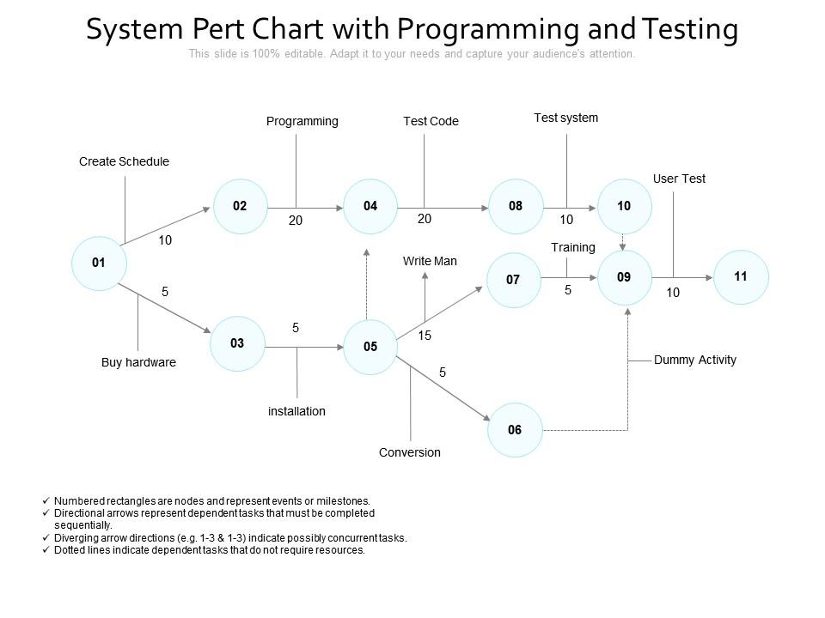

*Figure 6 pert chart testing*

## 5.4 Implementation

Is when the majority of the code for the program is written. This phase involves the actual installation of the newly-developed system. This step puts the project into production by moving the data and components from the old system and placing them in the new system via a direct cutover. While this can be a risky and complicated move, the cutover typically happens during off-peak hours, thus minimizing the risk. Both system analysts and end-users should now see the realization of the project that has implemented changes.

## 5.5 System modules codes

**Home page**

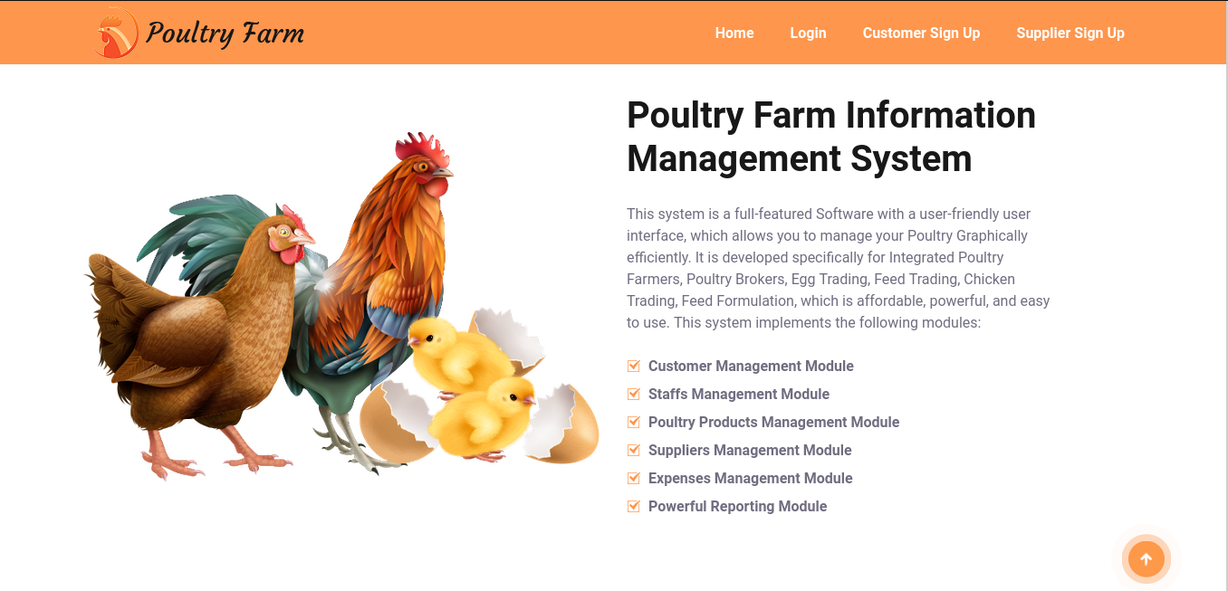

**Home page source codes**

<div class="container">

<div class="row align-items-center mb-15">

<div class="col-lg-6 col-12">

<div class="about-thumb">

<img src="cms_assets/images/about/01.png" alt="about-thumb">

</div>

</div>

<div class="col-lg-6 col-12">

<div class="about-wrapper p-0">

<div class="about-title">

<h2><span class="d-lg-block"> Poultry Farm Information </span>Management System</h2>

<p>This system is a full-featured Software with a user-friendly user interface,

which allows you to manage your Poultry Graphically efficiently.

It is developed specifically for Integrated Poultry Farmers,

Poultry Brokers, Egg Trading, Feed Trading, Chicken Trading,

Feed Formulation, which is affordable, powerful, and easy to use. This system implements the following modules:

</p>

</div>

<div class="about-content">

<ul class="lab-ul list-group">

<li class="list-group-item py-1 px-0 border-none"><i class="icofont-tick-boxed mr-2 color-theme"></i>Customer Management Module</li>

<li class="list-group-item py-1 px-0 border-none"><i class="icofont-tick-boxed mr-2 color-theme"></i>Staffs Management Module</li>

<li class="list-group-item py-1 px-0 border-none"><i class="icofont-tick-boxed mr-2 color-theme"></i>Poultry Products Management Module</li>

<li class="list-group-item py-1 px-0 border-none"><i class="icofont-tick-boxed mr-2 color-theme"></i>Suppliers Management Module</li>

<li class="list-group-item py-1 px-0 border-none"><i class="icofont-tick-boxed mr-2 color-theme"></i>Expenses Management Module</li>

<li class="list-group-item py-1 px-0 border-none"><i class="icofont-tick-boxed mr-2 color-theme"></i>Powerful Reporting Module</li>

</ul>

</div>

</div>

</div>

</div>

</div>

</section>

**Login page**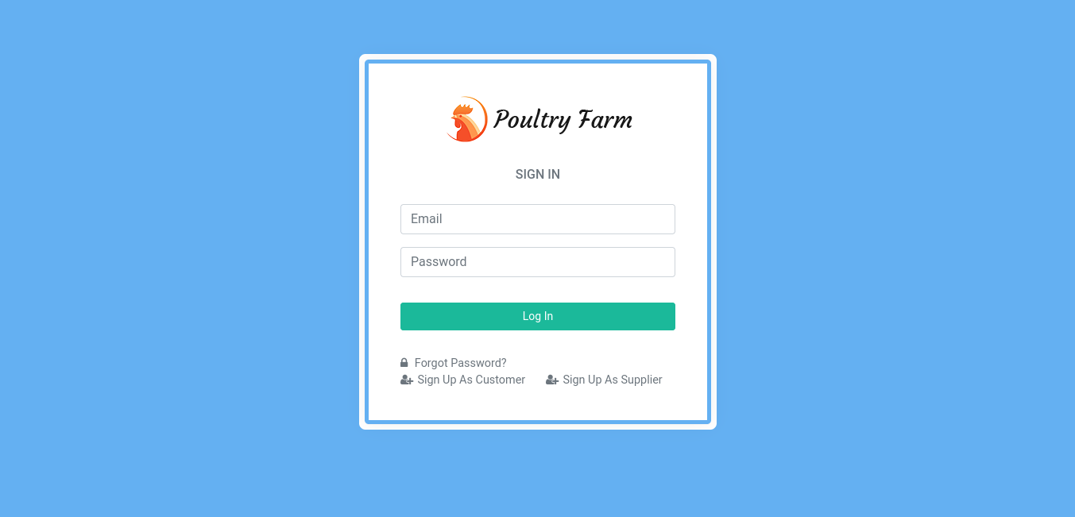

**Login page source codes**

<div class="wrapper-page">

<div class="account-bg">

<div class="card-box mb-0">

<div class="text-center m-t-20">

<a href="" class="logo text-warning">

<img src="cms_assets/images/logo/01.png" alt="">

</a>

</div>

<div class="m-t-10 p-20">

<div class="row">

<div class="col-12 text-center">

<h6 class="text-muted text-uppercase m-b-0 m-t-0">Sign In</h6>

</div>

</div>

<form class="m-t-20" method="POST">

<div class="form-group row">

<div class="col-12">

<input class="form-control" type="text" name="user_email" required placeholder="Email">

</div>

</div>

<div class="form-group row">

<div class="col-12">

<input class="form-control" name="user_password" type="password" required placeholder="Password">

</div>

</div>

<div class="form-group row">

<div class="col-12">

</div>

</div>

<div class="form-group text-center row m-t-10">

<div class="col-12">

<button class="btn btn-success btn-block waves-effect waves-light" name="Login" type="submit">Log In</button>

</div>

</div>

<div class="form-group row m-t-30 mb-0">

<div class="col-12">

<a href="reset_password" class="text-muted"><i class="fa fa-lock m-r-5"></i> Forgot Password?</a>

</div>

<div class="col-6">

<a href="user_sign_up?access=customer" class="text-muted"><i class="fa fa-user-plus m-r-5"></i>Sign Up As Customer</a>

</div>

<div class="col-6">

<a href="user_sign_up?access=supplier" class="text-muted"><i class="fa fa-user-plus m-r-5"></i>Sign Up As Supplier</a>

</div>

</div>

</form>

</div>

<div class="clearfix"></div>

</div>

</div>

<!-- end card-box-->

</div>

**Sign up page**

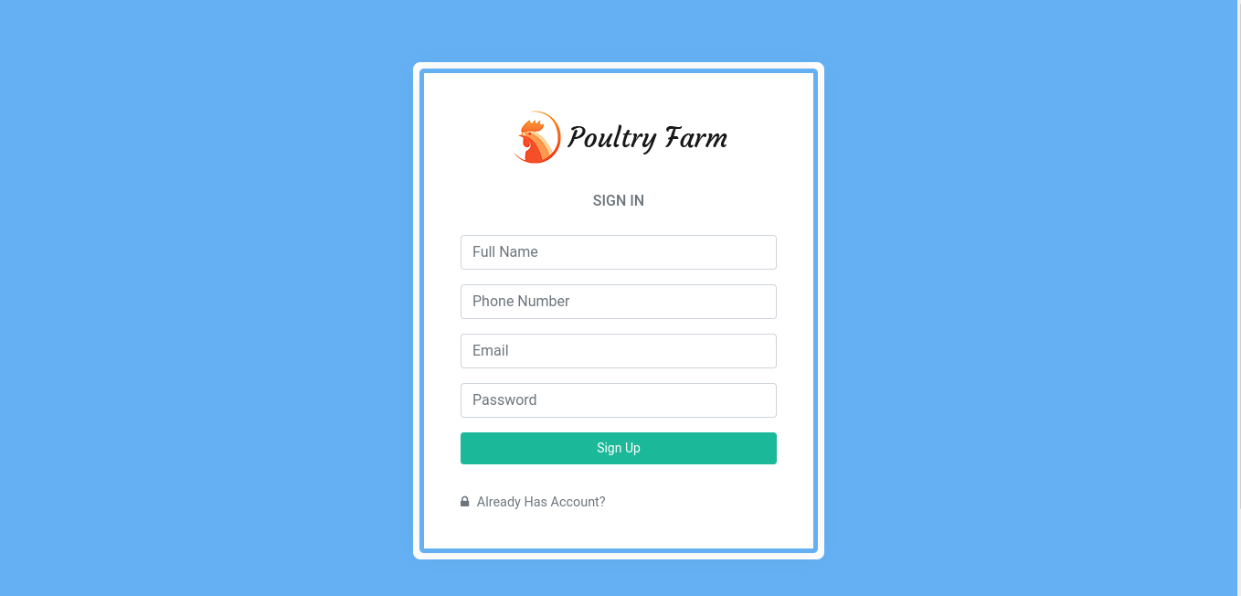

**Sign up page source codes**

<div class="account-bg">

<div class="card-box mb-0">

<div class="text-center m-t-20">

<a href="" class="logo text-warning">

<img src="cms_assets/images/logo/01.png" alt="">

</a>

</div>

<div class="m-t-10 p-20">

<div class="row">

<div class="col-12 text-center">

<h6 class="text-muted text-uppercase m-b-0 m-t-0">Sign In</h6>

</div>

</div>

<form class="m-t-20" method="POST">

<div class="form-group row">

<div class="col-12">

<input class="form-control" type="text" name="user_name" required placeholder="Full Name">

</div>

</div>

<div class="form-group row">

<div class="col-12">

<input class="form-control" type="text" name="user_phone_no" required placeholder="Phone Number">

</div>

</div>

<div class="form-group row">

<div class="col-12">

<input class="form-control" type="text" name="user_email" required placeholder="Email">

</div>

</div>

<div class="form-group row">

<div class="col-12">

<input class="form-control" name="user_password" type="password" required placeholder="Password">

</div>

</div>

<div class="form-group text-center row m-t-10">

<div class="col-12">

<button class="btn btn-success btn-block waves-effect waves-light" name="Sign_Up" type="submit">Sign Up</button>

</div>

</div>

<div class="form-group row m-t-30 mb-0">

<div class="col-12">

<a href="login" class="text-muted"><i class="fa fa-lock m-r-5"></i> Already Has Account?</a>

</div>

</div>

</form>

</div>

<div class="clearfix"></div>

</div>

</div>

**Dashboards - Admin Module**

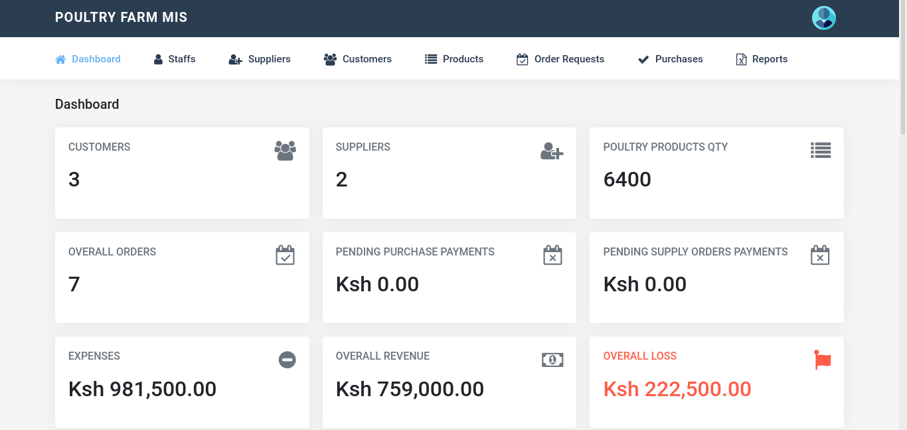

**Dashboards - Admin module source codes**

<div class="wrapper">

<div class="container">

<!-- Page-Title -->

<div class="row">

<div class="col-sm-12">

<div class="page-title-box">

<h4 class="page-title">Dashboard</h4>

</div>

</div>

</div>

<div class="row">

<div class="col-md-6 col-xl-4">

<div class="card-box tilebox-one">

<i class="fa fa-users fa-3x float-right text-muted"></i>

<h6 class="text-muted text-uppercase m-b-20">Customers</h6>

<h2 class="m-b-20" data-plugin="counterup">3</h2>

</div>

</div>

<div class="col-md-6 col-xl-4">

<div class="card-box tilebox-one">

<i class="fa fa-user-plus float-right text-muted"></i>

<h6 class="text-muted text-uppercase m-b-20">Suppliers</h6>

<h2 class="m-b-20" data-plugin="counterup">2</h2>

</div>

</div>

<div class="col-md-6 col-xl-4">

<div class="card-box tilebox-one">

<i class="fa fa-list float-right text-muted"></i>

<h6 class="text-muted text-uppercase m-b-20">Poultry Products Qty</h6>

<h2 class="m-b-20"><span data-plugin="counterup">6400</span></h2>

</div>

</div>

<div class="col-md-6 col-xl-4">

<div class="card-box tilebox-one">

<i class="fa fa-calendar-check-o float-right text-muted"></i>

<h6 class="text-muted text-uppercase m-b-20">Overall Orders</h6>

<h2 class="m-b-20"><span data-plugin="counterup">7</span></h2>

</div>

</div>

<div class="col-md-6 col-xl-4">

<div class="card-box tilebox-one">

<i class="fa fa-calendar-times-o float-right text-muted"></i>

<h6 class="text-muted text-uppercase m-b-20">Pending Purchase Payments</h6>

<h2 class="m-b-20" data-plugin="counterup">Ksh 0.00</h2>

</div>

</div>

<div class="col-md-6 col-xl-4">

<div class="card-box tilebox-one">

<i class="fa fa-calendar-times-o float-right text-muted"></i>

<h6 class="text-muted text-uppercase m-b-20">Pending Supply Orders Payments</h6>

<h2 class="m-b-20" data-plugin="counterup">Ksh 0.00</h2>

</div>

</div>

<div class="col-md-6 col-xl-4">

<div class="card-box tilebox-one">

<i class="fa fa-minus-circle float-right text-muted"></i>

<h6 class="text-muted text-uppercase m-b-20">Expenses</h6>

<h2 class="m-b-20" data-plugin="counterup">Ksh 981,500.00</h2>

</div>

</div>

<div class="col-md-6 col-xl-4">

<div class="card-box tilebox-one">

<i class="fa fa-money float-right text-muted"></i>

<h6 class="text-muted text-uppercase m-b-20">Overall Revenue</h6>

<h2 class="m-b-20"><span data-plugin="counterup">Ksh 759,000.00</span></h2>

</div>

</div>

<div class="col-md-6 col-xl-4 text-danger">

<div class="card-box tilebox-one">

<i class="fa fa-fa fa-exclamation-triangle float-right text-danger"></i>

<h6 class="text-danger text-uppercase m-b-20">Overall Loss</h6>

<h2 class="m-b-20"><span data-plugin="counterup">Ksh 222,500.00</span></h2>

</div>

</div>

</div>

<!-- end row -->

<div class="row">

<div class="col-lg-12 col-xl-12">

<div class="card-box">

<h4 class="header-title m-t-0 m-b-20">Recent Customer Purchase Orders</h4>

<table id="datatable-buttons" class="table table-bordered mb-0">

<thead>

<tr>

<th>Product Details</th>

<th>Customer</th>

<th>Order Details</th>

<th>Order Status</th>

</tr>

</thead>

<tbody>

<tr>

<th>

WEDXO09653 Exotic Eggs </th>

<td>Name: Todd James <br>

Phone : 0790023495 </td>

<td>

Order # : 03864GQZXR<br>

Order QTY: 900<br>

Payment Amt: Ksh 9,000.00<br>

Date: 21 Feb 2022 </td>

<td>

<span class="badge badge-success">Paid</span>

</td>

</tr>

<tr>

<th>

PIYKT57314 Broilers </th>

<td>Name: James Doe Jnr <br>

Phone : 6677553423256 </td>

<td>

Order # : 06135TDRZL<br>

Order QTY: 1500<br>

Payment Amt: Ksh 750,000.00<br>

Date: 21 Feb 2022 </td>

<td>

<span class="badge badge-success">Paid</span>

</td>

</tr>

</tbody>

</table>

</div>

</div><!-- end col-->

<div class="col-lg-12 col-xl-12">

<div class="card-box">

<h4 class="header-title m-t-0 m-b-20">Recent Supplier Orders</h4>

<table id="datatable-buttons" class="table table-bordered mb-0">

<thead>

<tr>

<th>Product Details</th>

<th>Supplier</th>

<th>Order Details</th>

<th>Order Status</th>

</tr>

</thead>

<tbody>

<tr>

<th>

WEDXO09653 Exotic Eggs </th>

<td>Name: James Doe <br>

Phone : 08877666321 </td>

<td>

Order # : 06324EPCFH<br>

Order QTY: 900<br>

Payment Amt: Ksh 9,000.00<br>

Date: 21 Feb 2022 </td>

<td>

<span class="badge badge-success">Paid</span>

</td>

</tr>

<tr>

<th>

EBQDL38729 Indengenous Eggs </th>

<td>Name: James Doe <br>

Phone : 08877666321 </td>

<td>

Order # : 03269UAHFO<br>

Order QTY: 1500<br>

Payment Amt: Ksh 22,500.00<br>

Date: 21 Feb 2022 </td>

<td>

<span class="badge badge-success">Paid</span>

</td>

</tr>

<tr>

<th>

PIYKT57314 Broilers </th>

<td>Name: Supplier Doe James <br>

Phone : 097865432 </td>

<td>

Order # : 43028KNERY<br>

Order QTY: 500<br>

Payment Amt: Ksh 250,000.00<br>

Date: 21 Feb 2022 </td>

<td>

<span class="badge badge-success">Paid</span>

</td>

</tr>

<tr>

<th>

PIYKT57314 Broilers </th>

<td>Name: James Doe <br>

Phone : 08877666321 </td>

<td>

Order # : 67210DGMHN<br>

Order QTY: 900<br>

Payment Amt: Ksh 450,000.00<br>

Date: 21 Feb 2022 </td>

<td>

<span class="badge badge-success">Paid</span>

</td>

</tr>

<tr>

<th>

PIYKT57314 Broilers </th>

<td>Name: Supplier Doe James <br>

Phone : 097865432 </td>

<td>

Order # : 97468UNAXR<br>

Order QTY: 500<br>

Payment Amt: Ksh 250,000.00<br>

Date: 21 Feb 2022 </td>

<td>

<span class="badge badge-success">Paid</span>

</td>

</tr>

</tbody>

</table>

</div>

</div><!-- end col-->

</div>

<!-- end row -->

</div> <!-- container -->

<!-- Footer -->

<footer class="footer">

2021 - 2022 © One Hen Poultry Farm Information Management System.

</footer> <!-- End Footer -->

**Customer Module**

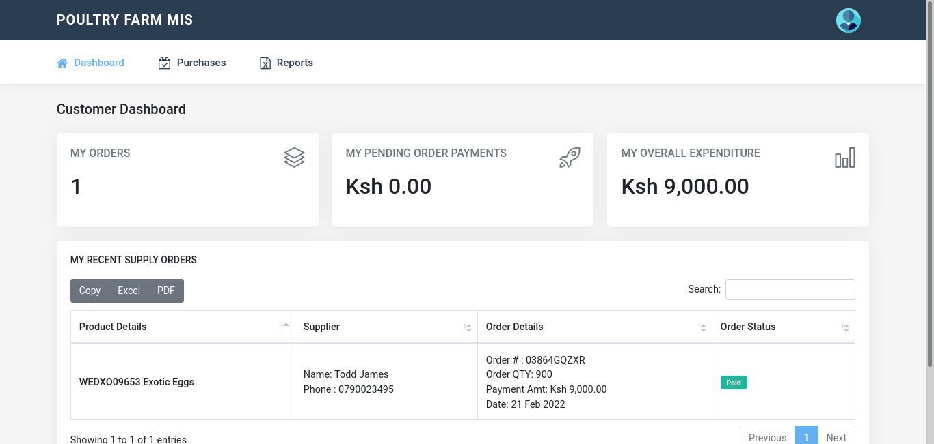

**Customer module source codes**

<div class="wrapper">

<div class="container">

<!-- Page-Title -->

<div class="row">

<div class="col-sm-12">

<div class="page-title-box">

<h4 class="page-title">Customer Dashboard</h4>

</div>

</div>

</div>

<div class="row">

<div class="col-md-6 col-xl-4">

<div class="card-box tilebox-one">

<i class="icon-layers float-right text-muted"></i>

<h6 class="text-muted text-uppercase m-b-20">My Orders</h6>

<h2 class="m-b-20" data-plugin="counterup">1</h2>

</div>

</div>

<div class="col-md-6 col-xl-4">

<div class="card-box tilebox-one">

<i class="icon-rocket float-right text-muted"></i>

<h6 class="text-muted text-uppercase m-b-20">My Pending Order Payments</h6>

<h2 class="m-b-20" data-plugin="counterup">Ksh 0.00</h2>

</div>

</div>

<div class="col-md-6 col-xl-4">

<div class="card-box tilebox-one">

<i class="icon-chart float-right text-muted"></i>

<h6 class="text-muted text-uppercase m-b-20">My Overall Expenditure</h6>

<h2 class="m-b-20"><span data-plugin="counterup">Ksh 9,000.00</span></h2>

</div>

</div>

</div>

<!-- end row -->

<div class="row">

<div class="col-lg-12 col-xl-12">

<div class="card-box">

<h4 class="header-title m-t-0 m-b-20">My Recent Supply Orders</h4>

<table id="datatable-buttons" class="table table-bordered mb-0">

<thead>

<tr>

<th>Product Details</th>

<th>Supplier</th>

<th>Order Details</th>

<th>Order Status</th>

</tr>

</thead>

<tbody>

<tr>

<th>

WEDXO09653 Exotic Eggs </th>

<td>Name: Todd James <br>

Phone : 0790023495 </td>

<td>

Order # : 03864GQZXR<br>

Order QTY: 900<br>

Payment Amt: Ksh 9,000.00<br>

Date: 21 Feb 2022 </td>

<td>

<span class="badge badge-success">Paid</span>

</td>

</tr>

</tbody>

</table>

</div>

</div><!-- end col-->

</div>

<!-- end row -->

</div> <!-- container -->

**Supplier Module**

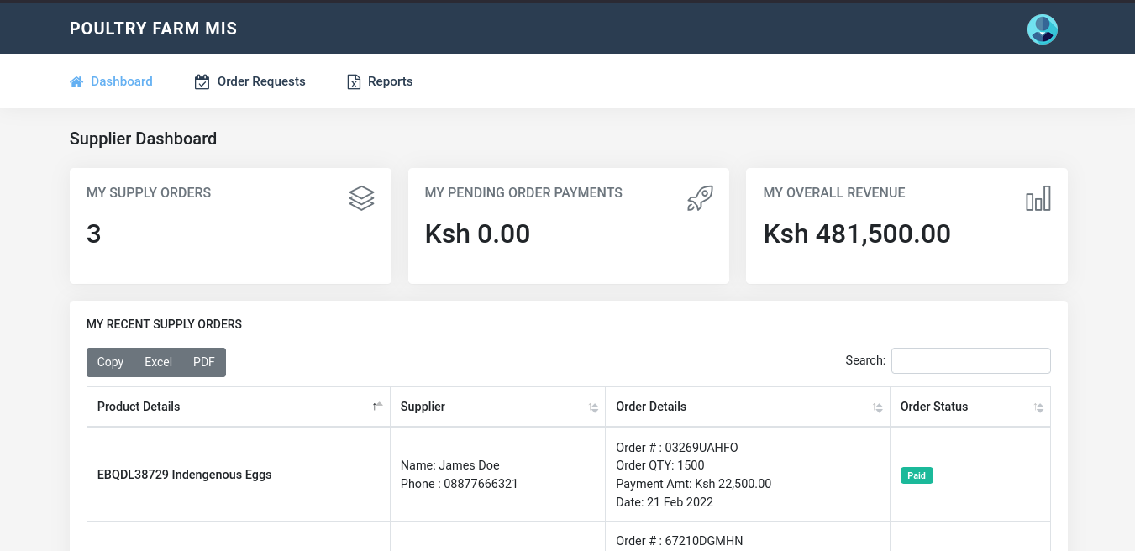

**Supplier module source code**

<div class="wrapper">

<div class="container">

<!-- Page-Title -->

<div class="row">

<div class="col-sm-12">

<div class="page-title-box">

<h4 class="page-title">Supplier Dashboard</h4>

</div>

</div>

</div>

<div class="row">

<div class="col-md-6 col-xl-4">

<div class="card-box tilebox-one">

<i class="icon-layers float-right text-muted"></i>

<h6 class="text-muted text-uppercase m-b-20">My Supply Orders</h6>

<h2 class="m-b-20" data-plugin="counterup">3</h2>

</div>

</div>

<div class="col-md-6 col-xl-4">

<div class="card-box tilebox-one">

<i class="icon-rocket float-right text-muted"></i>

<h6 class="text-muted text-uppercase m-b-20">My Pending Order Payments</h6>

<h2 class="m-b-20" data-plugin="counterup">Ksh 0.00</h2>

</div>

</div>

<div class="col-md-6 col-xl-4">

<div class="card-box tilebox-one">

<i class="icon-chart float-right text-muted"></i>

<h6 class="text-muted text-uppercase m-b-20">My Overall Revenue</h6>

<h2 class="m-b-20"><span data-plugin="counterup">Ksh 481,500.00</span></h2>

</div>

</div>

</div>

<!-- end row -->

<div class="row">

<div class="col-lg-12 col-xl-12">

<div class="card-box">

<h4 class="header-title m-t-0 m-b-20">My Recent Supply Orders</h4>

<table id="datatable-buttons" class="table table-bordered mb-0">

<thead>

<tr>

<th>Product Details</th>

<th>Supplier</th>

<th>Order Details</th>

<th>Order Status</th>

</tr>

</thead>

<tbody>

<tr>

<th>

WEDXO09653 Exotic Eggs </th>

<td>Name: James Doe <br>

Phone : 08877666321 </td>

<td>

Order # : 06324EPCFH<br>

Order QTY: 900<br>

Payment Amt: Ksh 9,000.00<br>

Date: 21 Feb 2022 </td>

<td>

<span class="badge badge-success">Paid</span>

</td>

</tr>

<tr>

<th>

PIYKT57314 Broilers </th>

<td>Name: James Doe <br>

Phone : 08877666321 </td>

<td>

Order # : 67210DGMHN<br>

Order QTY: 900<br>

Payment Amt: Ksh 450,000.00<br>

Date: 21 Feb 2022 </td>

<td>

<span class="badge badge-success">Paid</span>

</td>

</tr>

<tr>

<th>

EBQDL38729 Indengenous Eggs </th>

<td>Name: James Doe <br>

Phone : 08877666321 </td>

<td>

Order # : 03269UAHFO<br>

Order QTY: 1500<br>

Payment Amt: Ksh 22,500.00<br>

Date: 21 Feb 2022 </td>

<td>

<span class="badge badge-success">Paid</span>

</td>

</tr>

</tbody>

</table>

</div>

</div><!-- end col-->

</div>

<!-- end row -->

</div> <!-- container -->

# CHAPTER SIX

# SYSTEM MAINTENANCE

After the program is released, the system enters the stage of continual maintenance. Today, any software product must be examined for defects on a regular basis and updated with new features, big and small. Your system may work well when it is first released, but flaws might appear at any time. In terms of updates, your software solution must be able to react to the rapidly changing demands of its end customers. To create changes, developers will collaborate with testers. In the future, I plan to extend this system functionalities and consume payment gateways so that customer orders will be wired directly to their accounts.

# CONCLUSION

**The problem and solution**

In One Hen Poultry Farm, have problems that hinders their daily activities

which include; loss of data since there is no proper record keeping, a lot of expenses that the

Firm incurs when they order and supplying of the poultry products produced, the

customers also have a lot of challenges since they have to go there so that they can be able to order which is a tiresome process and it also needs a lot of expenses. In order to solve these problems.

# PROJECT TIME SCHEDULED

|  |  |  |  |  |  |  |
| --- | --- | --- | --- | --- | --- | --- |
| **Task description** | **Task duration in weeks** | **Proposed start date** | **Proposed end date** | **Actual start date** | **Actual start end time** | **Deliverable** |
| Project identification | 1 | 10/8/2021 | 25/8/2021 |  |  | Data |
| Problem analysis | 2 | 28/8/2021 | 12/9/2021 |  |  | System analysis report |
| Proposal writing | 2 | 14/9/2021 | 28/9/2021 |  |  | Proposal documents |
| Proposal presentation | 1 | 30/9/2021 | 7/10/2021 |  |  | proposal |
| Feasibility study | 2 | 8/10/2021 | 22/10/2021 |  |  | Feasibility study |
| System design | 1 | 23/10/2021 | 30/10/2021 |  |  | design |
| System coding | 3 | 31/11/2021 | 23/11/2021 |  |  | System modules |
| System testing | 2 | 24/11/2021 | 8/12/2021 |  |  | Test results |
| system implementation | 2 | 9/12/2021 | 22/12/2021 |  |  | Executable system |
| System documentation | 1 | 23/12/2021 | 30/12/2021 |  |  | System documentation |
| Project presentation | 1 | 1/1/2022 | 8/1/2022 |  |  | Project presentation |

Table 3: project time schedule

## APPENDIXES

## PROJECT BUDGET

|  |  |  |  |
| --- | --- | --- | --- |
| ITEM NAME | UNIT | UNIT AMOUNT | AMOUNT |
| Computer | 1 | 25000 | 30000 |
| Flash disk 32 GB | 1 | 2000 | 2100 |
| Uninterrupted power supply | 1 | 2000 | 5000 |
| Modem | 1 | 1500 | 1500 |
| Printing papers | 1 rim | 500 | 500 |
| Antivirus | 1 | 2000 | 2000 |
| Printer EPSON | 1 | 4000 | 6000 |
| Travelling | 2 days | 2000 | 2000 |
| Other expenses |  | 3000 | 3000 |
| Total |  | 42000 | 52100 |

Table 4: project budget

## GANT CHART.

|  |  |  |  |  |  |  |  |  |  |  |  |  |
| --- | --- | --- | --- | --- | --- | --- | --- | --- | --- | --- | --- | --- |
| ACTIVITIES | AUG | | SEP | OCT | NOV | | DEC | JAN | FEB | | MARCH | |
| Project identification |  | |  |  |  | |  |  |  | |  | |
| Proposal writing |  | |  |  |  | |  |  |  | |  | |
| Proposal presentation |  | |  |  |  | |  |  |  | |  | |
| Feasibility study |  | |  |  |  | |  |  |  | |  | |
| System design |  | |  |  |  | |  |  |  | |  | |
| System coding |  | |  |  |  | |  |  |  | |  | |
| System testing |  | |  |  |  | |  |  |  | |  | |
| System documentation |  | |  |  |  | |  |  |  | |  | |
| System presentation |  |  | |  | |  | |  | |  | |  |

# References

“www.tyson foods .com.retrieved September 22, 2020. (2019). *abcde”Tyson*.

African, S. (. ((2018). agricultural sector .

familly poultry. (2006). *pym et al* .